**LPO 8852: Regression II**

**Vanderbilt University**

**At-Home Final Exam**

**December 6, 2024**

Name:

By signing below, I agree to the terms of Vanderbilt University’s honor code. I attest that I have not collaborated with, or received any external assistance from other individuals on this at-home exam.

Signature:

**Instructions:** Read each question carefully and provide clear, concise responses in your own document. Be sure to complete every part of every question. Partial credit will be given

where appropriate. If you make any assumptions to answer a question, please state those assumptions explicitly. Email your completed exam to sean.corcoran@vanderbilt.edu before 9:00 a.m. on **Saturday December 7**. Good luck!

**Question 1.** After Hurricane Katrina, the State of Louisiana took over the New Orleans public school district and enacted a wide set of school reforms, including converting most schools to privately-operated charter schools. One question of interest is how these reforms affected overall spending in New Orleans and spending on certain inputs, such as instructional and administrator salaries. Note these outcomes (e.g., total, instructional, and administrative spending per pupil) are all reported at the district level. (**23 points**)

1. One approach to this research question might be a difference-in-differences design. Briefly describe the data requirements, estimating equation, and assumptions necessary for this approach. (**5 points**)
2. An alternative approach would be a synthetic control design. When and why might this be preferable to the study you described in part (a)? (**3 points**)
3. Briefly describe how you would carry out a synthetic control study of post-Katrina public education spending, and any assumption(s) that must hold in order to interpret its findings as causal. (**5 points**)
4. Suppose that your approach in (c) found that spending in New Orleans *increased* in post-Katrina years, relative to other districts. How would you determine whether this difference was statistically significant or not? Briefly explain. (**5 points**)
5. State whether the following statement is true or false, and briefly justify your answer. (**5 points**)

*When conducting a synthetic control analysis with multiple outcomes (e.g., total expenditure per pupil and administrative salaries per pupil), it is important to use the same synthetic control for each outcome.*



**Question 2.** A well-known paper by Card & Giuliano (2016) examined the effects of a tracking program on high-achieving Black and Hispanic students in a large urban school district. In the district they studied, schools with at least one gifted 4th grader were required to create a separate “gifted/high achiever” (GHA) classroom. Most seats in these classrooms were filled by non-gifted students who ranked highest on the previous year’s end-of-grade test. The following figure shows the relationship between 3rd grade class rank and 4th grade assignment to a GHA classroom: (**36 points**)

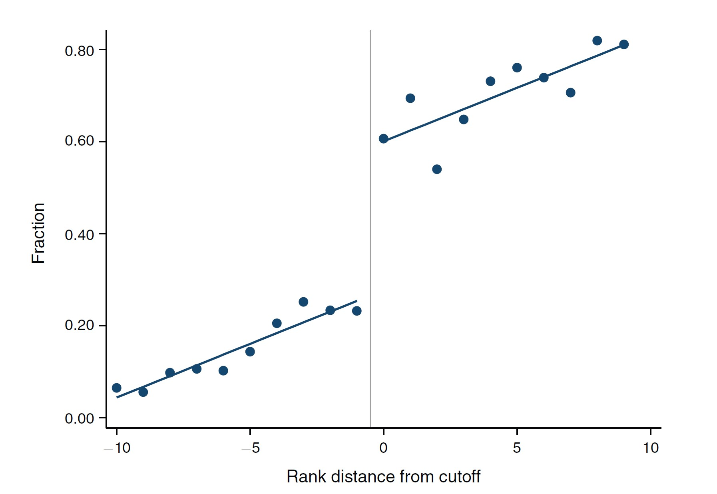

1. Briefly explain how these data might be used to support a regression discontinuity design analysis of the effects of GHA classroom assignment on later outcomes. (**5 points**)
2. What are the key assumptions required for causal interpretation of the modeling approach described in part (a). What might you do, if anything, to evaluate the plausibility of those assumptions? Carefully explain. (**8 points**)
3. The figure below was created using 4th grade test scores (shown on the *y*-axis). Consider the first two of these, for reading and math scores. True or false: the jump observed at *rank* = 0 is an estimate of the average treatment effect of GHA classroom assignment.

Explain your answer. (**5 points**)

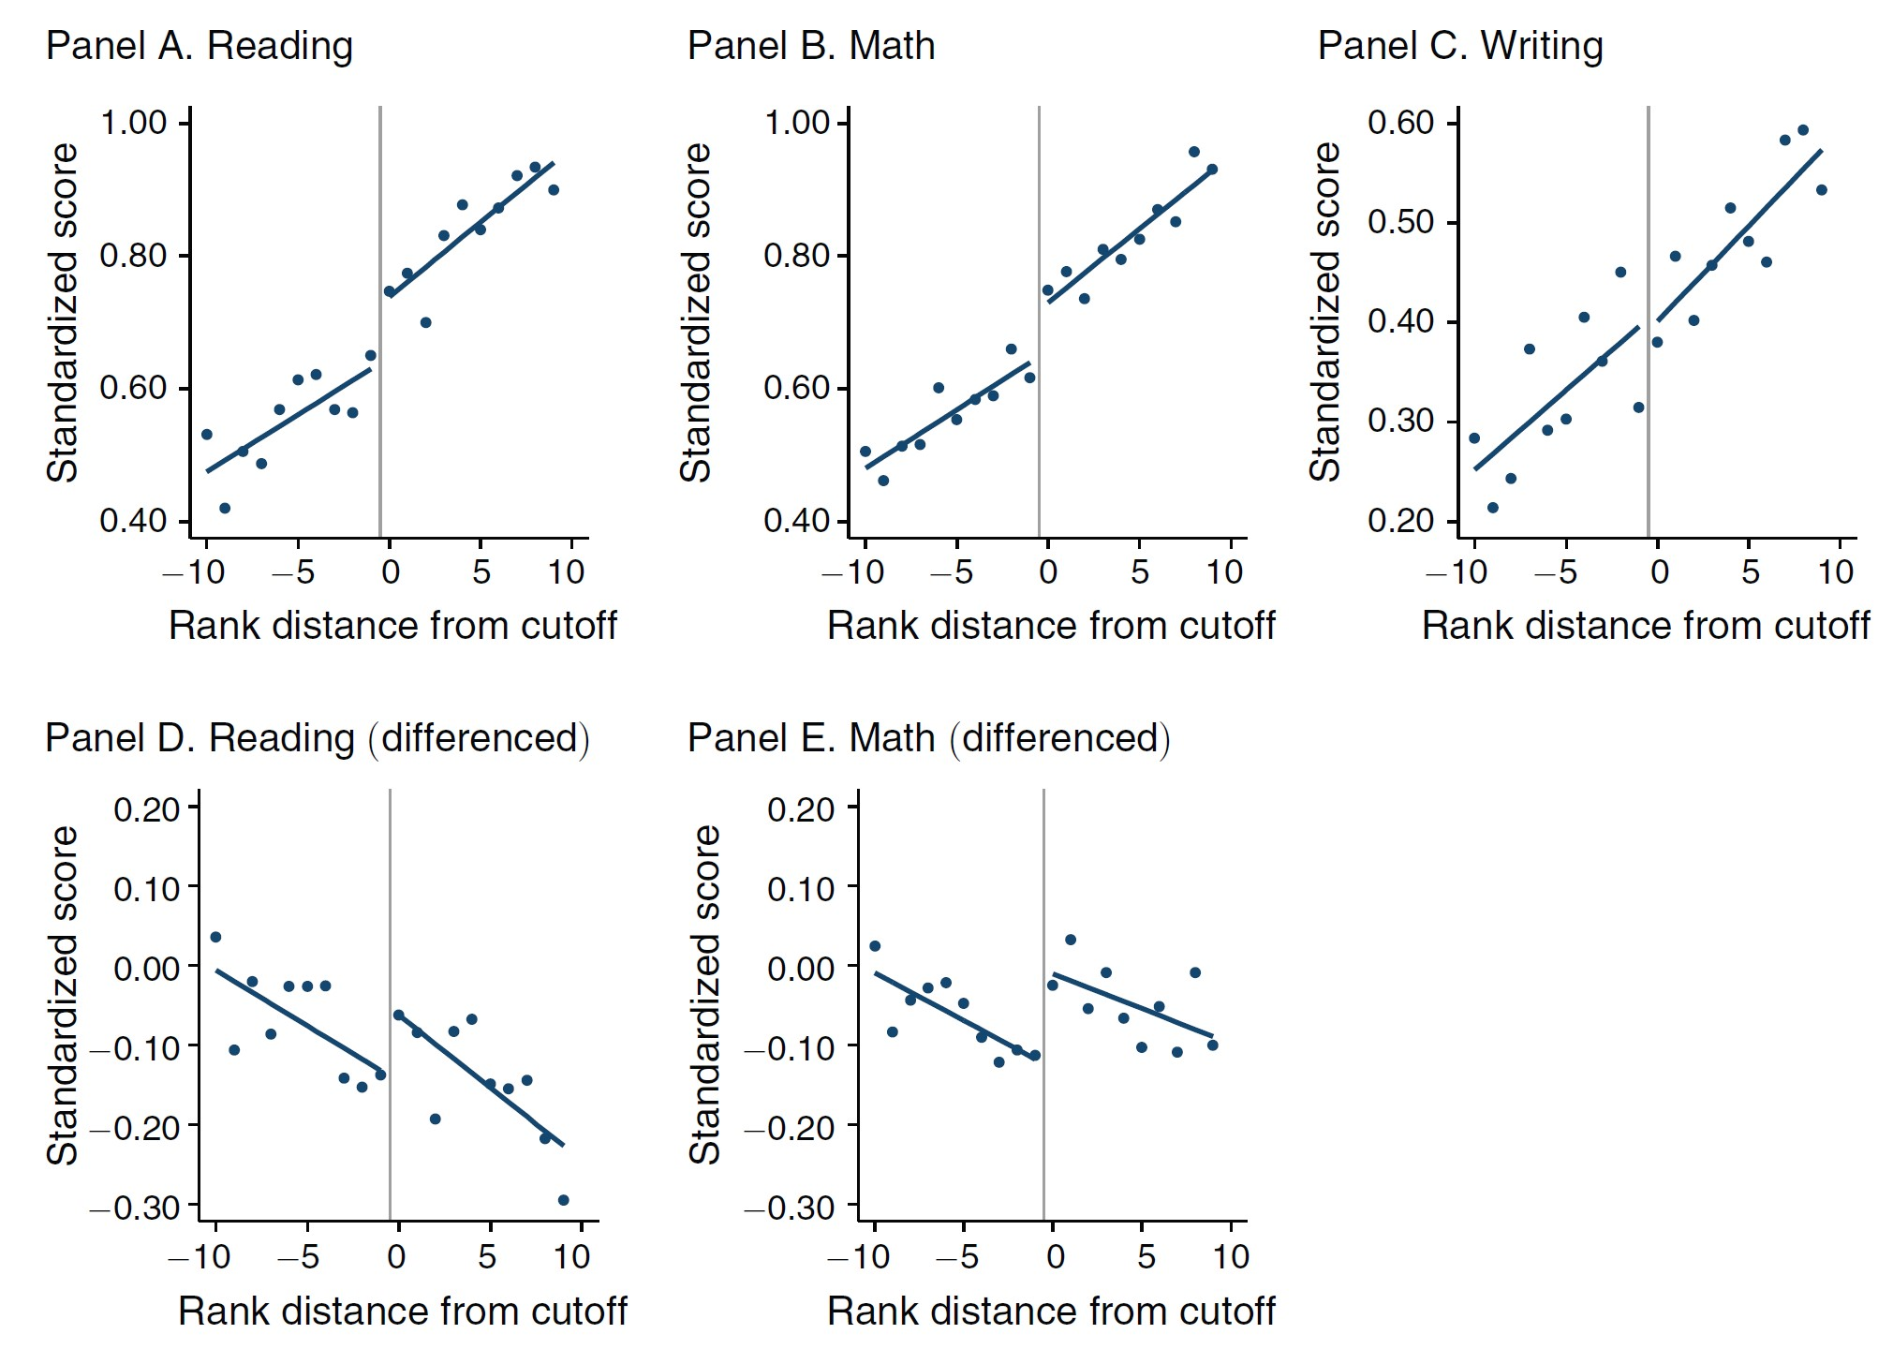

1. Carefully interpret the coefficient estimates in row 1, columns (1)-(5) below. What evidence do columns 1 and 2 provide regarding the identifying assumptions for causal inference? (**8 points**)

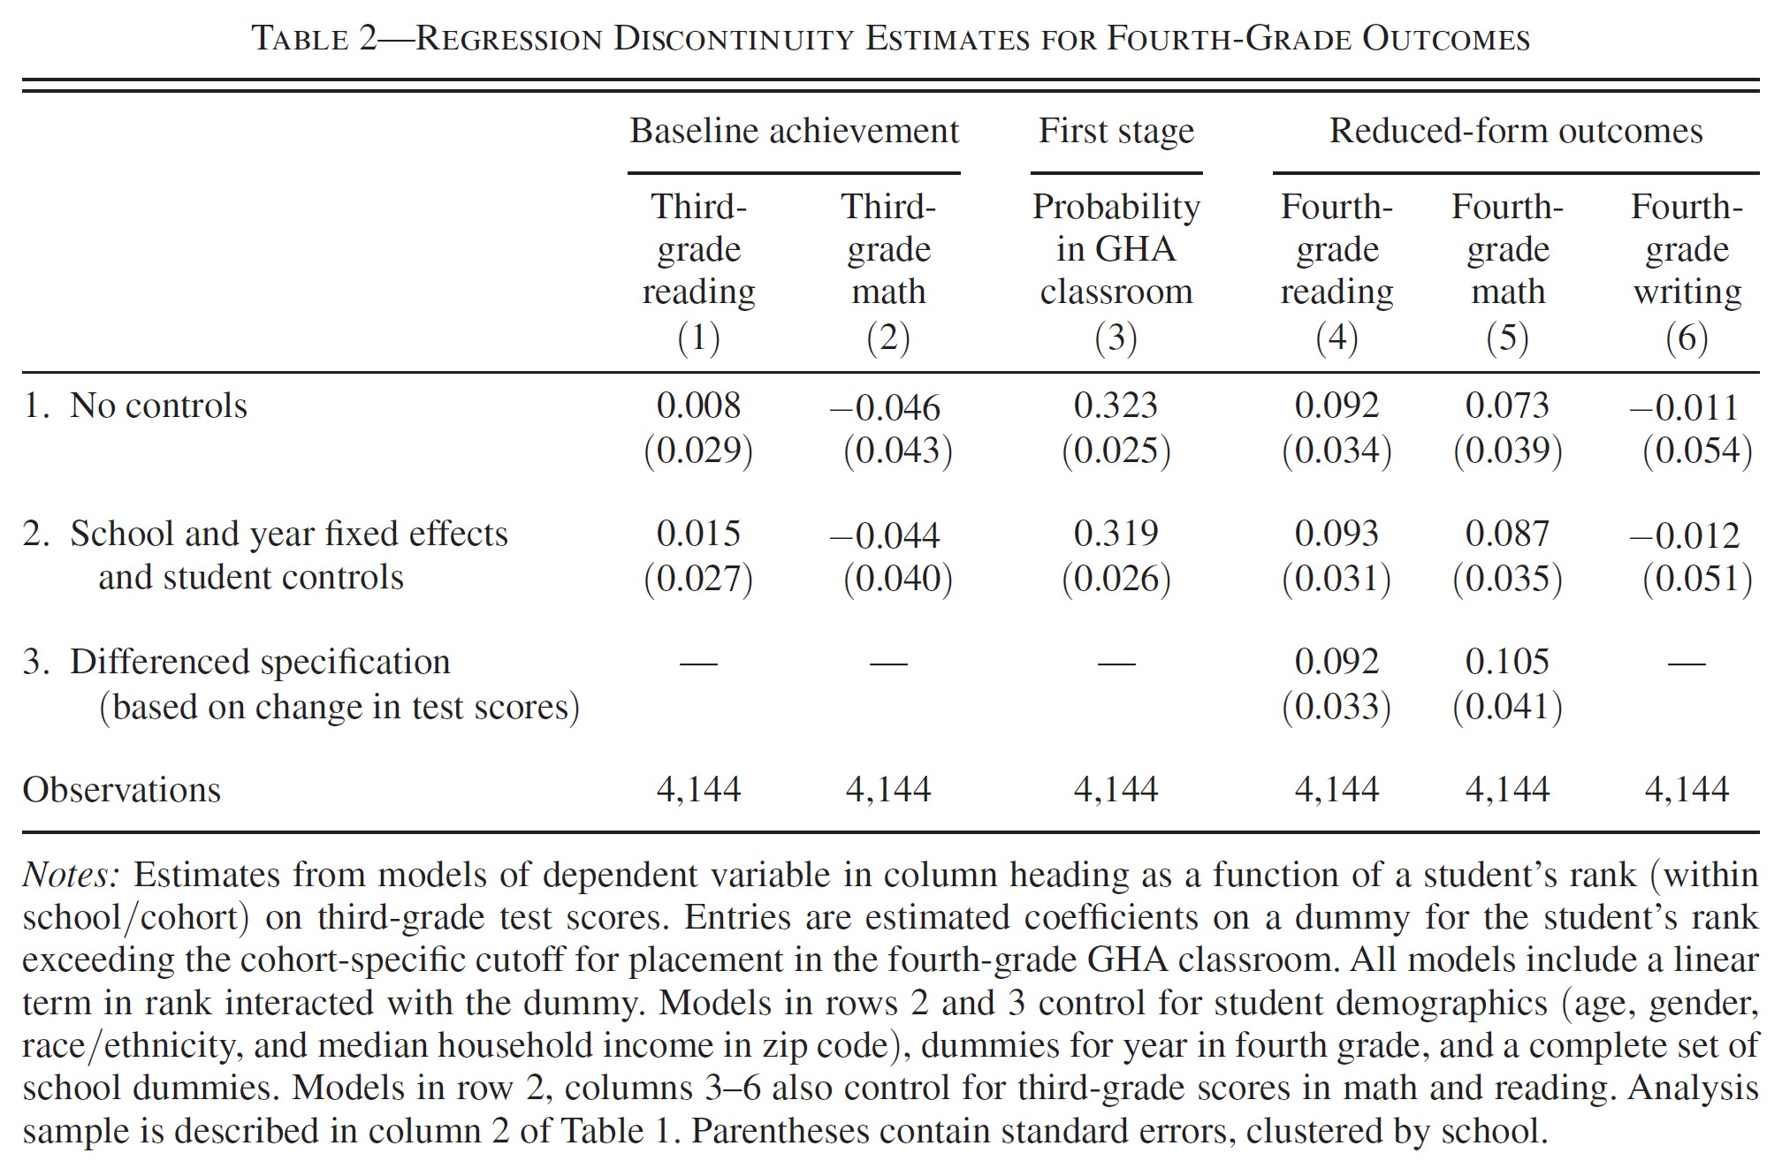

1. The coefficients in row 2 columns 4-5 (school and year fixed effects and student controls) are very similar to those in row 1. What might explain this, and what evidence does this provide for the identifying assumptions for causal inference? (**5 points**)
2. (Unrelated to parts a-e): State whether the following statement is true or false. If false, explain why. (**5 points**)

*If there is evidence of manipulation in the running variable in a regression discontinuity design, the treatment effect estimator will be biased.*

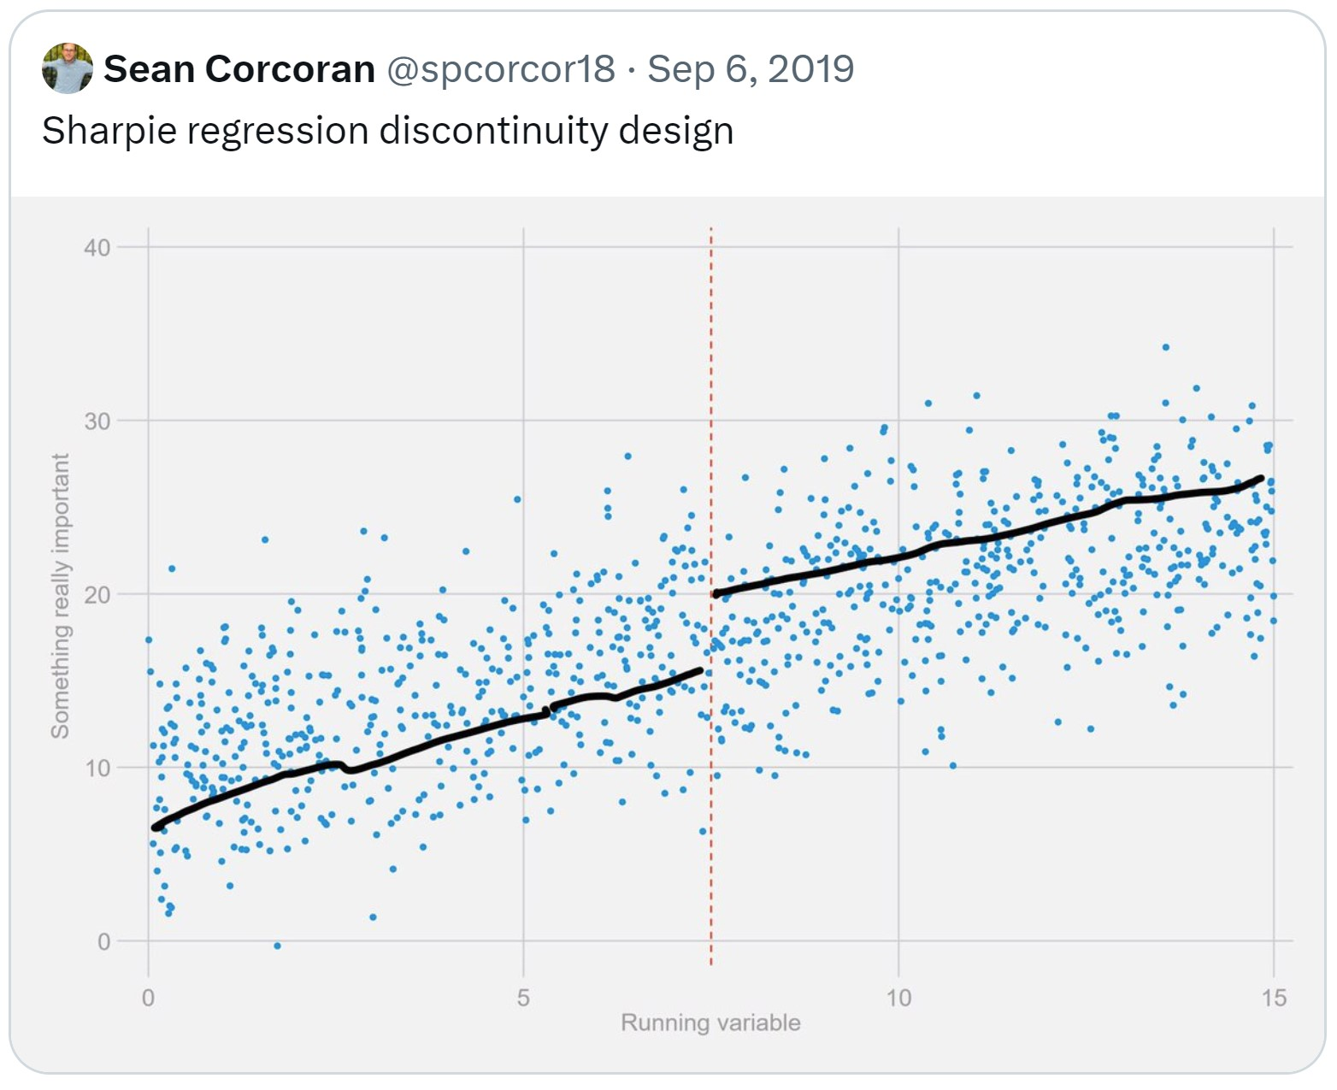

**Question 3.** Consider the following regression discontinuity model constructed to estimate the impact of greater health care spending on the mortality of at-risk infants. The design exploits the fact that many hospitals have rules requiring greater care for newborns with especially low birthweight. For example, in some hospitals, newborns with very low weight (those *<* 1500*g*) are sent directly to the neonatal intensive care units (NICU) or to hospital wards with greater nurse supervision. This design hopes to leverage the difference in health care at 1500*g* to estimate the benefits of greater health care spending on newborn outcomes. (**19 points**)

You have data on a large sample of children with low birth weights (1350 to 1650 *g*). The outcome of interest is 28-day mortality (*y* = 1 if the child dies within 28 days of birth). The key explanatory variable is hospital spending in dollars on the newborn (*x*). The two figures below show the relationship between birthweight and hospital spending (Figure A) and between birthweight and 28-day mortality (Figure B).

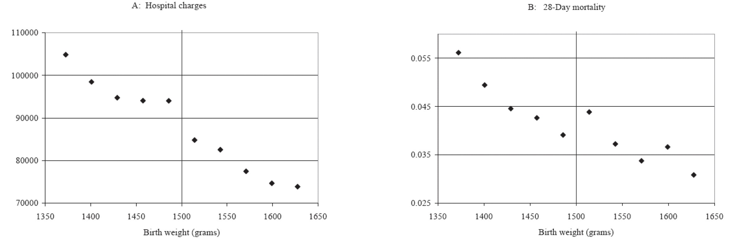

The table below reports coefficient estimates (and standard errors) for the following two regression equations, where *Di* = 1 if *BWi <* 1500:

*xi* = *α*0 + *α*1*BWi* + *α*2*Di* + *ui*

*yi* = *γ*0 + *γ*1*BWi* + *γ*2*Di* + *vi*

(Note: for this problem, it does not matter whether *BW* is centered at $1500)

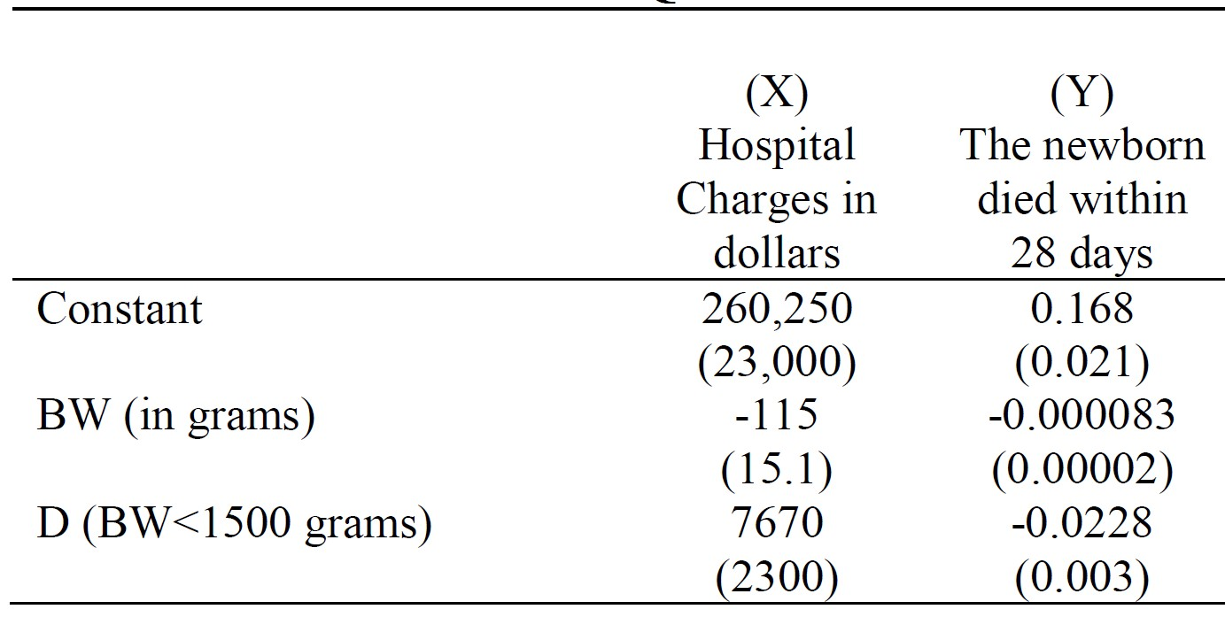

1. Using the results reported in the table above, calculate the 2SLS (fuzzy RD) estimate of the effect of increased hospital spending on 28-day infant mortality. Interpret this coefficient: what is your predicted change in 28-day mortality rate if spending on low birthweight newborns increases by $10,000? **(5 points)**
2. What assumptions must hold in order for the estimate in part (a) to be a consistent estimate of the causal impact of greater health care spending on newborn mortality? **(5 points)**
3. Suppose a public health advocate uses the results in part (a) to argue for more healthcare spending for newborns in general. Given what you know of RD, what word of caution would you have for this person? **(4 points)**
4. (Unrelated to parts a-c): State whether the following statement is true or false. If false, explain why. **(5 points)**

*If a researcher includes an instrumental variable z in in causal regression model of interest and obtains a statistically significant coefficient for z, the instrument is invalid.*

